**Sierra Leone country profile**

Published

5 April 2018

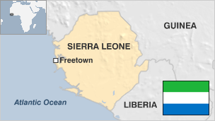

**Sierra Leone, a country in West Africa, has a special significance in the history of the transatlantic slave trade as the departure point for thousands of west African captives. The capital, Freetown, was founded as a home for repatriated former slaves in 1787.**

But the country's modern history has been overshadowed by a brutal civil war that ended in 2002 with the help of Britain, the former colonial power, and a large United Nations peacekeeping mission.

Sierra Leone has experienced substantial economic growth in recent years, although the ruinous effects of the civil war continue to be felt.

The country is also rich in diamonds and other minerals. The trade in illicit gems, known as "blood diamonds" for their role in funding conflicts, perpetuated the civil war. The government has sought to crack down on the trade.

* Read [more country profiles](http://news.bbc.co.uk/1/hi/country_profiles/) - Profiles by [BBC Monitoring](http://www.bbc.co.uk/monitoring)

**President: Julius Maada Bio**

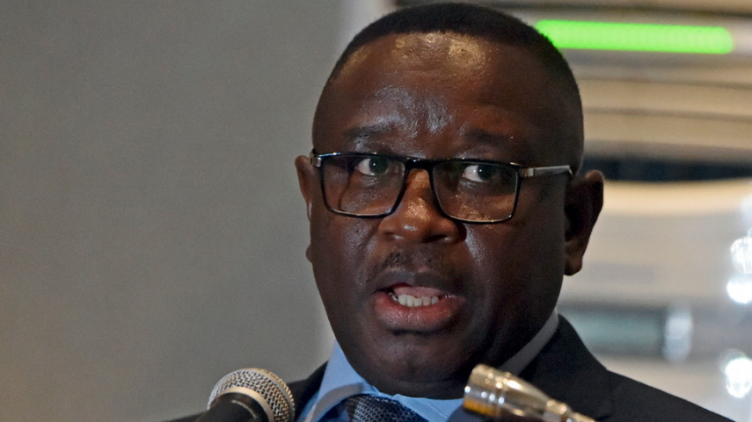image copyrightISSOUF SANOGO/AFP/Getty Images

Julius Maada Bio of the opposition Sierra Leone People's Party won a run-off election to become president in April 2018.

He narrowly beat governing All People's Congress candidate Samura Kamara, who said he will mount a legal challenge to the result over alleged voting irregularities.

Mr Maada Bio, a former soldier, took part in a military coup during the country's civil war in 1992, only to overthrow the military junta itself in 1996 and pave the way for free elections that year.

He has tried to counter criticism of human-rights standards during military rule by saying he accepted "collective responsibility" for any violations.

He became leader of the People's Party in 2012 and stood for the presidency the following year, losing to President Ernest Bai Koroma of the All People's Congress.

Mr Maada Bio has criticised the outgoing government's close ties with China, and pledged to heal the country's divisions and invest in education.

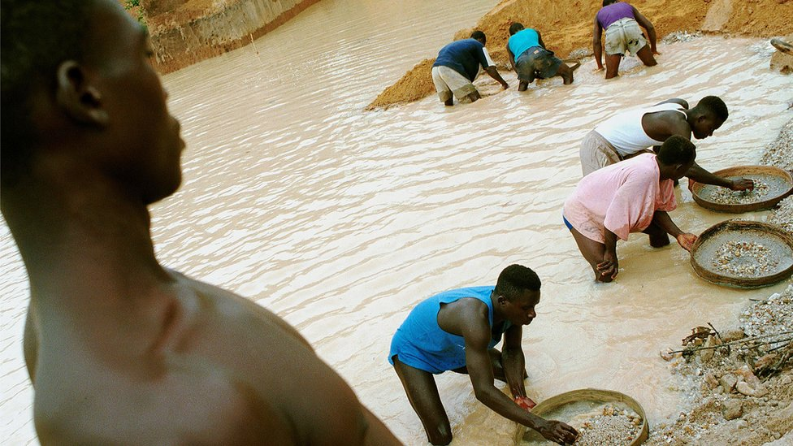image copyrightGetty Images

image captionSierra Leone's diamonds helped fund years of conflict

Media freedom in Sierra Leone has its limits; media rights monitors say high-level corruption is a taboo topic, with officials using libel laws to target errant journalists.

Challenges facing broadcasters include unreliable power supplies, poor funding and low advertising revenues. There are dozens of radio stations, most of them privately owned.

Dozens of newspapers are published in Freetown, despite low literacy levels.

# Sierra Leone profile - Timeline

Published

5 April 2018

**A chronology of key events**

**1787** - British abolitionists and philanthropists establish a settlement in Freetown for repatriated and rescued slaves.

**1808** - Freetown settlement becomes crown colony.

**1896** - Britain sets up a protectorate over the Freetown hinterland.

**1954** - Sir Milton Margai, leader of the Sierra Leone People's Party, appointed chief minister.

**1961** - Sierra Leone becomes independent.

**1967** - Military coup deposes Premier Siaka Stevens' government.

**1968** - Siaka Stevens returns to power at the head of a civilian government following another military coup.

**1971** - Sierra Leone declared a republic, Stevens becomes executive president.

**1978** - New constitution proclaims Sierra Leone a one-party state with the All People's Congress as the sole legal party.

**1985** - Maj-Gen Joseph Saidu Momoh becomes president following Stevens's retirement.

## War and coups

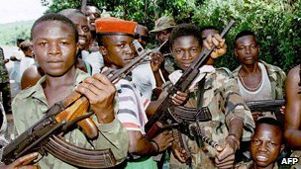image copyrightAFP

image captionRUF rebels waged a campaign of amputation and rape

**1991** - Start of civil war. Former army corporal Foday Sankoh and his Revolutionary United Front (RUF) begin campaign against President Momoh, capturing towns on border with Liberia.

**1991** September - New constitution providing for a multiparty system adopted.

**1992** - President Joseph Momoh ousted in military coup led by Capt Valentine Strasser, apparently frustrated by failure to deal with rebels. Under international pressure, Capt Strasser announces plans for the first multi-party elections since 1967.

**1996** January - Valentine Strasser ousted in military coup led by his defence minister, Brig Julius Maada Bio.

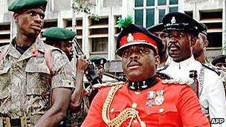image copyrightAFP

image captionJunta leader Major Johnny Paul Koroma suspended the constitution

**1996** - Ahmad Tejan Kabbah elected president in February, signs peace accord with Sankoh's rebels in November.

**1997** - Peace deal unravels. President Kabbah deposed by army in May. Maj Johnny Paul Koroma, in prison awaiting the outcome of a treason trial, leads the military junta - the Armed Forces Revolutionary Council (AFRC). Koroma suspends the constitution, bans demonstrations and abolishes political parties.

Kabbah flees to Guinea to mobilise international support.

**1997** July - The Commonwealth suspends Sierra Leone.

**1997** October - The UN Security Council imposes sanctions on Sierra Leone, barring the supply of arms and petroleum products. A British company, Sandline, nonetheless supplies "logistical support", including rifles, to Kabbah allies.

**1998** February - Nigerian-led West African intervention force Ecomog storms Freetown and drives rebels out.

**1998** March - Kabbah makes a triumphant return to Freetown amid scenes of public rejoicing.

**1999** January - Rebels backing Revolutionary United Front leader Foday Sankoh seize parts of Freetown from Ecomog. After weeks of bitter fighting they are driven out, leaving behind 5,000 dead and a devastated city.

## UN intervenes

**1999** May - A ceasefire is greeted with cautious optimism in Freetown amid hopes that eight years of civil war may soon be over.

**1999** July - Six weeks of talks in the Togolese capital, Lome, result in a peace agreement, under which the rebels receive posts in government and assurances they will not be prosecuted for war crimes.

**1999** November/December - UN troops arrive to police the peace agreement - but one rebel leader, Sam Bokari, says they are not welcome. Meanwhile, Ecomog troops are attacked outside Freetown.

**2000** April/May - UN forces come under attack in the east of the country, but far worse is in store when first 50, then several hundred UN troops are abducted.

**2000** May - Rebels close in on Freetown; 800 British paratroopers sent to Freetown to evacuate British citizens and to help secure the airport for UN peacekeepers; rebel leader Foday Sankoh captured.

**2000** August - Eleven British soldiers are taken hostage by a renegade militia group called the West Side Boys.

## Disarming rebels

**2000** September - British forces mount operation to rescue remaining UK hostages.

**2001** January - Government postpones presidential and parliamentary elections - set for February and March - because of continuing insecurity.

**2001** March - UN troops for the first time begin to deploy peacefully in rebel-held territory.

**2001** May - Disarmament of rebels begins, and British-trained Sierra Leone army starts deploying in rebel-held areas.

**2002** January - War declared over. UN mission says disarmament of 45,000 fighters is complete. Government, UN agree to set up war crimes court.

**2002** May - Kabbah wins a landslide victory in elections. His Sierra Leone People's Party secures a majority in parliament.

**2002** July - British troops leave Sierra Leone after their two-year mission to help end the civil war.

**2003** July - Rebel leader Foday Sankoh dies of natural causes while awaiting trial for war crimes.

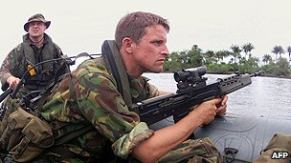image copyrightAFP

image captionForeign troops, such as these British soldiers, intervened in the conflict in Sierra Leone

**2003** August - President Kabbah tells truth and reconciliation commission that he had no say over operations of pro-government militias during war.

**2004** February - Disarmament and rehabilitation of more than 70,000 civil war combatants officially completed.

## War crimes trials

**2004** June - UN-backed war crimes war crimes trials begin.

**2004** September - UN hands control of security in capital over to local forces.

**2005** August - UN Security Council authorises opening of a UN assistance mission in Sierra Leone from 2006, to follow departure of peacekeepers in December.

**2005** December - The last UN peacekeeping troops leave Sierra Leone, marking the end of a five-year mission to restore order.

**2006** March - Liberian ex-president Charles Taylor is arrested in Nigeria and handed over to the war crimes court in Sierra Leone which indicted him.

**2006** December - President Kabbah says 90% of the country's $1.6bn (£815m) debt has been written off after negotiations with international creditors.

## Taylor trial

**2007** June - Start of former Liberian President Charles Taylor's war crimes trial in The Hague, where he stands accused of instigating atrocities in Sierra Leone.

Sierra Leone's special war crimes court in Freetown delivers its first verdicts, finding three militia leaders guilty.

**2007** August - Presidential and parliamentary polls. Ernest Bai Koroma wins the presidency and his All People's Congress, formerly in opposition, wins a majority in parliament.

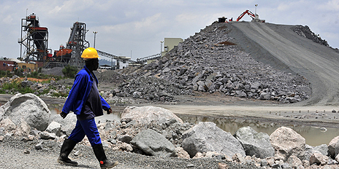image copyrightGetty Images

image captionDiamond mining is a major activity in the Kono district, in eastern Sierra Leone

**2009** October - UN-backed Special Court winds down after seven years investigating civil war atrocities. Its remaining case, the trial of Charles Taylor, continues in The Hague.

**2010** September - UN Security Council lifts last remaining sanctions against Sierra Leone - an arms embargo and a travel ban for rebels.

**2012** February - Energy companies report discovery of oil off the coasts of Liberia and Sierra Leone. Work continues to estimate their size.

**2012** April - The UN-backed Sierra Leone war crimes court in The Hague concludes its work with the conviction of former Liberian leader Charles Taylor of aiding and abetting war crimes in the Sierra Leone civil war.

**2012** November - First elections for since the end of the civil war held without UN oversight. President Koroma wins a second term.

**2013** April - Sierra Leone deploys a battalion of troops to Somalia to join the African Union peacekeeping mission.

## Ebola epidemic

**2014** July - Sierra Leone declares a state of emergency to tackle the deadly Ebola outbreak which has killed more than 700 in West Africa.

**2014** August - President Ernest Bai Koroma dismisses Health Minister Miatta Kargbo over her handling of the Ebola epidemic that has killed more than 400 people in Sierra Leone.

**2014** September - People in Sierra Leone are instructed to stay indoors for three days, as part of the country's strategy to stop the spread of the deadly Ebola virus.

**2015** March - Vice-President Samuel Sam-Sumana seeks asylum in US embassy, claiming his life is in danger. President Koroma accuses him of fomenting violence, and dismisses him.

**2016** March - The World Health Organisation declares Sierra Leone Ebola-free for a second time, after a new flare-up in the wake of the first all-clear in November.

**2018** April - Former military Julius Maada Bio ruler wins presidential election as Sierra Leone People's Party candidate, beating Samura Kamara of the governing All People's Congress. Mr Kamara says he will mount a legal challenge to the result.